WORKSHOP
DEVELOPMENT PARTNERSHIP CONFERENCE ON MINE ACTION IN VIETNAM
On 14 March 2014
1 | VN calls on donors to help with clean up of explosives
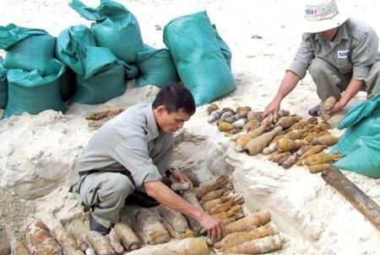

Mine and bomb clearance staff from the German non-government organisation, Solidarity Service International, disarm explosives in Quang Tri Province. More than 100,000 hectares of land was cleared of bombs and mines between 2012 and 2013.— VNA/VNS Photo Ho Cau
HA NOI (VNS)— More than of 100,000 hectares of land were cleared of bombs and mines during 2012 and 2013, but it would take Viet Nam many years and billions of dollars to finish the job completely, officials said yesterday.
At a development partnership conference on mine action yesterday, Prime Minister Nguyen Tan Dung called on international donors and organisations to increase their support for the country's efforts, and assist victims of bombs and mines.
"Although we have enjoyed peace for decades, the aftermath of the wars remains a big problem for the country," Dung said.
"Almost every locality of Viet Nam has areas heavily contaminated with bombs, mines and other unexploded ordnance, which will take a long time and significant resources to clear," he added.
According to the National Mine Action Programme for 2010-25, sometimes referred to as Programme 504, about 6.6 million ha, equivalent to 22 per cent of Viet Nam's land mass, is thought to be contaminated.
Since 1975, unexploded ordnance (UXO) has killed more than 40,000 people and injured over 60,000.
Currently, donor countries provided aid to support mine action in Viet Nam primarily through international organisations and non-governmental organisations with an average of about US$5-7 million a year, according to statistics from Programme 504.
The Government has spent about $30 million a year on mine clearance work and $50 million for resettlements and social security in recent years.
Lieutenant General Nguyen Chi Vinh, deputy minister of defence and member of the State Steering Committee for Programme 504, said the resources required for the post-war de-mining efforts were still limited – coupled with problems such as a lack of equipment to handle undersea activities, emergency aid for victims and research and development of de-mining equipment.
"It is a war we are fighting during peacetime and Programme 504 has a lot to do," Vinh said.
That included calling for more direct international funding as the Government estimated it could only meet half of the demand, officials said.
Since 2010, Programme 504 has compiled data in 49 out of 63 provinces on bombs and mines nationwide, and found that 7,645 communes were contaminated with unexploded ordnance.
Deputy Assistant Secretary Samuel Perez said helping Viet Nam to address UXOs was a priority for the US, and US Secretary of State John Kerry had signed an agreement in December 2013 to further co-operation.
"Viet Nam's commitment to a transparent and inclusive national programme on mine action is an encouraging development," Perez said. "While resources are critical to implementing mine action activities, they must be co-ordinated and applied to a clear set of priorities which requires openness and information sharing between Government and donors."
At the conference, other foreign representatives also agreed with the need to establish the Mine Action Partnership Group, which will serve as a policy dialogue with current and potential mine action donors, mine action international NGOs, the private sector and the local civil organisations.
The Viet Nam National Mine Action Center, which was officially launched yesterday at the conference, will be tasked with co-ordinating the programme, organising mine action associations and mobilising domestic resources. — VNS
http://vietnamnews.vn/society/252370/vn-calls-on-donors-to-help-with-clean-up-of-explosives.html

2 | Development partners commit to landmine clearance


Development partners at a March 14 conference were resolute in their commitment to provide Vietnam technical and financial assistance, share experiences and support victims of post-war unexploded ordnance (UXO).
To this end, they expect in return, to receive Vietnam’s close cooperation in information exchange, data provision, and international experience sharing on matters related to the disposal of bombs and mines.
They acknowledged Vietnam’s valiant effort in overcoming the consequences of leftover bombs and mines, and in fulfilling international commitment in the field.
The partners pledged to work closely with the newly established Vietnam National Mine Action Centre to speed up mine clearing efforts.
Addressing the Hanoi conference, Prime Minister Nguyen Tan Dung called on the US to make greater and more practical contributions to searching, cleaning up and overcoming the consequences of bombs and mines left over from the war.
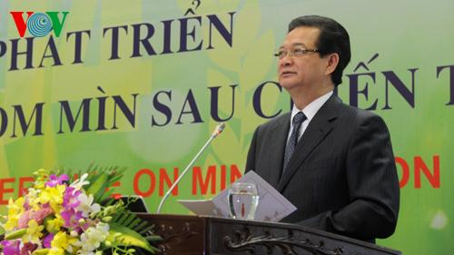
PM Nguyen Tan Dung speaking at the conference
He noted though the war ended nearly 40 years ago, it continues to cause heavy consequences in Vietnam. Unexploded ordnance has been found in almost all provinces and cities, affecting socio-economic development and human life.
On average more than 1,500 people die and nearly 2,300 others are seriously wounded from bomb and mine explosions every year. Many of the victims are children
The PM said the Vietnamese government has paid special attention to research, finalised the management system, and poured more investment into UXO removal.
A national programme of action on settling the consequences of unexploded ordnance (programme 504) has been established to guide the work.
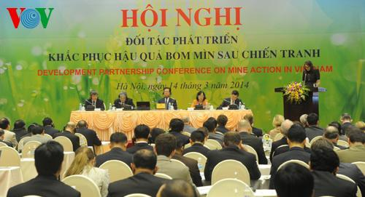
As a result, Vietnam has cleaned up tens of thousands of hectares of contaminated land, drawn a national map on UXO, and implemented a number of UXO clearance projects.
The Ministry of Foreign Affairs, the Ministry of Planning and Investment, and Committee 504 have jointly developed negotiation plans and signed cooperation agreements with the governments and organisations of foreign countries, to mobilise aid for programme 504.
The PM called on donors to support the Vietnamese Government and Committee 504 in settling the consequences of war aftermath, as well as in mobilising and utilising foreign aid effectively.
“Let’s stand and work together to build trust, maintain peace, and strengthen friendship and development cooperation to bring safety and happiness to all people,” Dung said.
“Let’s join hands to prevent wars and armed conflicts so that all countries and people will no longer suffer the horrendous consequences caused by leftover bombs and mines.”
To date Vietnam has signed memoranda of understanding on UXO disposal and support for victims with the US, the Geneva International Centre for Humanitarian Demining (GICHD) and the International Centre.
It has also worked out cooperation programmes with the United Nations Development Programme (UNDP), and the Norwegian People’s Aid (NPA), as well as within the ASEAN Defence Ministers’ Meeting Plus (ADMM+).
http://www.dtinews.vn/en/news/017002/33820/-development-partners-commit-to-landmine-clearance--.html

3 | Vietnam needs concrete support to accelerate the removal of the threat from mines and UXO

PANO – The Development Partnership Conference on Mine Action in Vietnam, opened on March 14th in Hanoi, attracted special attention from domestic and international donors to the Vietnam’s National Mine Action Programme (Programme 504).
Addressing the conference, Vietnamese Prime Minister Nguyen Tan Dung stressed that areas in almost every locality of Vietnam are heavily contaminated with bombs, mines and other unexploded ordnances, which will take a long time and significant resources to be cleared. Accidents relating to bombs and mines still occur, representing calamities for households and local communities.

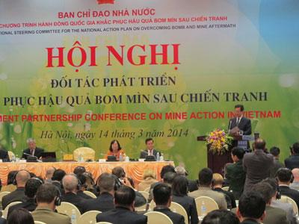
PM Nguyen Tan Dung addressing the conference
The Prime Minister said that Vietnamese government and its army has been proactively clearing bombs and mines and achieved significant results. Recently, the government has paid special attention and efforts to strengthen monitoring and management systems, spent significant resources for survey and clearance, and issued the National Mine Action Program and the Action Plan to 2015 period. This serves as a good foundation to mobilize recourses and assets within Vietnam and from abroad to accelerate land release and mine removal for socio-economic development.
However, as the explosives contamination is so serious, Vietnam really needs assistance and support from all governments, international organizations, non-governmental organizations, concerned individuals and communities to join efforts to speed up the removal of bombs and mines, to secure people’s livelihoods and to assist victims of bombs and mines to reintegrate into society.
Prime Minister Nguyen Tan Dung took this opportunity to call on donors, ambassadors and international friends for their participation in the Partnership Group to give advice and recommendations to Vietnam, as well as to establish contacts with other international donors for their support to the implementation of Program 504 which will turn Vietnam into a country free of the impact of mines and UXO.
Many representatives of embassies and international organizations also took the floor to praise the Vietnamese government’s efforts in overcoming the consequences of post-war bombs and mines in the country.
Meanwhile, they also suggested Vietnam to consider to join international conventions to share experiences and get better support from the international community.
Norwegian ambassador to Vietnam welcomed the recent establishment of the National Mine Action Program of Vietnam, saying that it will be an important step in the long-term efforts of Vietnam to address the problem of contamination by landmines, cluster munitions and other explosive remnants of war. The ambassador hoped that Vietnam would play the role of a regional torch bearer for the Convention on Cluster Munitions in the near future.
“That torch of solidarity would shine bright, and send a very strong humanitarian signal to all,” he stressed.
At this conference, the government of Vietnam and development partners agreed on the general principles of the group. The Mine Action Partnership Group will be the forum for developing deeper understanding, building consensus and facilitating progress towards common systems and methodologies in Program 504 and mark the beginning of a dialogue between the Government of Vietnam and development partners on strategic issues in mine action.
At the conference, the Charge d’Affaires of German Embassy, Mr Hans-Jörg Brunner, delivered a joint statement on behalf of the embassies of the United States, Japan, Germany, Ireland, as well as the United Nations Development Program in Vietnam.
“We applaud the Government’s plans to establish the Vietnam Mine Action Centre. Strong, effective and engaged national coordination is necessary to mobilize the full capacities of Vietnam and its international partners to face the challenge of contamination of explosive remnants of war,” he said.
He reiterated the commitment to find innovative and appropriate means to support the Vietnam’s mine action efforts.
In 2013, the Expert Working Group on Humanitarian Mine Action was launched within the frame of the ASEAN Defense Ministers Meeting – Plus, co-chaired by Vietnam and India in 2013-2015. In addition, in September 2013 at the United National General Assembly, the Prime Minister announced Vietnam’s commitment to contributing to demining units as part of United Nations Peacekeeping Missions.

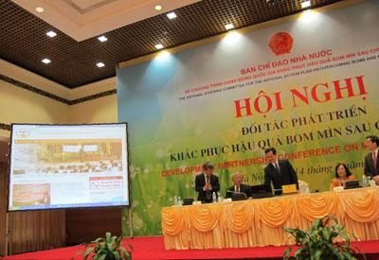
The Programme 504's webiste, www.vnmac.gov.vn, launched at the conference

These are important indicators of the growing cooperation between Vietnam and the international mine action cooperation. The Programme 504 Standing Agency Chief, Senior Lieutenant General Nguyen Chi Vinh, said in an interview on March 12th that Vietnam would increase international integration in mine action by participating in global mine action events and entering bilateral and multilateral agreements in mine action.
“This will help the international community better understand Vietnam’s mine action program,” said Lieutenant General Nguyen Chi Vinh.
Working closely with the national authorities in mine action since 2000, Country Director of Vietnam Veterans of America Foundation (IC-VVAF) Thao Nguyen said: “There were tragic accidents in December 2013 and January 2014 in Vinh Long, Dong Nai, and Quang Binh, claiming the death of seven children and five other casualties – all born after the war ended in 1975.”
“This reminds us all that UXO contamination in Vietnam remains widespread across the country, and demining is a long-term process and an urgent task for Vietnam. As cooperation increases with the US, and other international partners, Vietnam will be better able to accelerate the implementation of the national mine action program,” said Ms. Nguyen.
With support from the US government, IC-VVAF provides funding and technical assistance to the 504 Office organizing this Vietnam Development Partnership Conference on Mine Action. In 2014, IC-VVAF also co-chairs the Landmine Working Group of international and national mine action NGOs in Vietnam.
Ngoc Hung
http://www.qdnd.vn/qdndsubsite/en-US/75/291912/print/Default.aspx

4 | Vietnam needs 300 years to clear UXOs
Vietnam may need as long as 300 years to clear all unexploded explosive weapons, collectively called unexploded ordnance (UXOs), left over from wartime, according to a national UXOs clearance agency official.
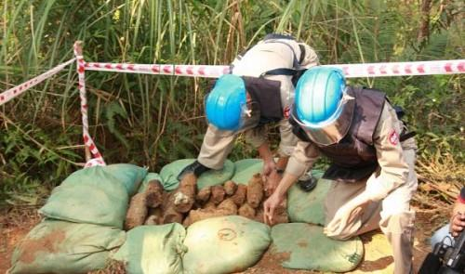
> > Boy loses 4 limbs, 2 others injured by UXO
Pham Quang Xuan, deputy head of the Steering Committee for the National Action Program on Settling Consequences of UXOs , made the statement at a press briefing on a conference of international donors for UXOs in Vietnam that will be held in the country in mid-March.
About 800,000 tonnes of bombs, mines, and other explosive weapons were left over and buried in Vietnam after its resistance war against American invaders from 1954 to 1975, Xuan said.
In the past years, only 3.26 percent of the country’s total areas contaminated with UXOs were cleared.
All 63 provinces and cities in the country have been contaminated with UXOs, but the clearance has only been carried out in some northern provinces such as Ha Giang and Lang Son and six central provinces including Thanh Hoa, Nghe An, Ha Tinh , Quang Binh, Quang Tri and Quang Ngai, Xuan said.
The aforesaid steering committee has set a target of clearing all UXOs in these six provinces in the next five years.
To fulfill the target, besides mobilizing domestic resources, the Vietnamese government has been calling for contribution and assistance from foreign non-governmental agencies and international organizations.
100,000 casualties
Since 1975, explosions of bombs, mines, and other weapons have killed more than 40,000 people and injured about 60,000 others in Vietnam, according to preliminary statistics, said Xuan, the deputy head.
UXOs have not only posed risks of death or injury, but also seriously affected the country’s socio-economic development, as Vietnam has to spend thousands of billions of dong (VND1 billion = US$47,170) each year on UXO clearance and supporting victims of UXOs.
Over the past 20 years, many international donors have supported Vietnam’s efforts to clear UXOs with a total contribution of $10-15 million every year, Don Tuan Phong , Vice President of the Vietnam Union of Friendship Organizations, was quoted by VietNamNet as saying.
http://www.vietnambreakingnews.com/2014/03/vietnam-needs-300-years-to-clear-uxos/#.UyZ6a85RLIU

5 | PM calls for int’l support for tackling UXOs consequences
Prime Minister Nguyen Tan Dung has called on international donors, including the U.S., to give further assistance to Vietnam in dealing with consequences caused by unexploded ordnance (UXOs) in the Southeast Asian country.
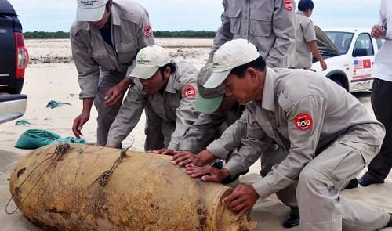
Premier Dung made the appeal at the Development Partnership on Mine Action Conference in Hanoi on Friday.
The event was organized by the State Steering Committee on the National Action Program on Settling Consequences of UXOs.
The leader also called for support in mobilizing resources and improving the efficiency of the use of those resources in activities to mitigate such consequences.
Due to many wars, both the land and people of Vietnam have been heavily affected by a large volume of bombs and mines, many of which are still unexploded, the government leader said.
Currently, over 20 percent of the country’s total land area has been contaminated with UXOs.
Many accidents related to UXOs have occurred, causing casualties, and affecting the use of land, forest and water resources, and the life of people, PM Dung said.
The Vietnamese government has introduce mechanisms and policies to clear UXOs and spent state money dealing with UXOs aftermaths.
Explosions of bombs, mines, and other weapons have killed more than 42,000 people and injured about 62,000 others in Vietnam since 1975, according to preliminary statistics.
On average, UXOs annually kill more than 1,500 people and injure nearly 2,300 others, including many children.
After the Vietnam War ended in 1975, the Vietnamese government and the Vietnam People’s Army have taken many measures to cope with UXOs aftermaths.
The government spends US$80-100 million resolving UXOs issues every year and has received support from domestic as well as international organizations.
As a result, tens of thousands of hectares of land have been cleared off UXOs.
Vietnam has also drawn maps of UXOs areas in the country and many UXO clearance projects have been implemented effectively.
With a view to continue achieving good performance in UXOs clearance, the PM appealed to international donors, ambassadors of other countries and international friends to support the Vietnamese government’s efforts to surmount UXOs consequences.
He also asked Vietnam’s concerned agencies to work with one another on cooperating with the governments of other countries and international organizations in clearing UXOs and coping with UXOs aftermaths.
On April 21, 2010, the government issued Decision 504 to approve the 2010-2025 national plan for dealing with bomb and mine aftermaths so as to mobilize domestic resources and international support for UXO clearance.
Vietnam has signed an MoU with the U.S. government, the Geneva International Center for Humanitarian Demining (GICHD) and International Center.
It already agreed to a cooperation framework with UNDP, and has been cooperating with other international organizations in relation to UXO clearance.
In 2012 and 2013, UXOs have been cleared on nearly 100,000 hectares of land in Vietnam and many projects have been carried out to call for support from donors and to educate the public on the prevention of UXOs-related accidents, PM Dung said.
A national bomb and mine action center made its debut at the conference the same day at the conference.
Call for U.S. actions
On behalf of the Vietnamese government and people, PM Dung called on the U.S. government, with its conscience and responsibility, to make more contributions to the detection and clearance of UXOs and to help mitigate consequences caused by UXOs left over during the war in Vietnam.
“Let’s build trust, keep peace, strengthen friendships and cooperation for mutual development, and bring safety and happiness to everyone. We should decisively prevent all wars, all armed conflicts so that all nations and peoples in the world are no longer exposed to heartbroken consequences brought about by UXOs,” PM Dung said.
Vietnam’s attempts to settle UXOs aftermaths were highly appreciated by Samuel Perez, a Deputy Assistant Secretary of State , Stefano Toscan, director of the GICHD, many foreign ambassadors to Vietnam, and other delegates from international organizations.
They affirmed that their countries and organizations will continue providing assistance to Vietnam in settling UXOs issues and in supporting UXOs victims in the near future, through a joint statement of donors and non-government organizations.
They also hoped to closely cooperate with Vietnam in information exchange, data provision, and experience sharing when it comes to the country’s action plan for coping with bomb and mine aftermaths.
They expressed their belief that the newly-established national bomb and mine action center will facilitate their activities to support Vietnam in the UXOs area in the future.
At a press conference held in March 2014, Pham Quang Xuan , deputy head of the State Steering Committee on the National Action Program on Settling Consequences of UXOs , said Vietnam may need as long as 300 years to clear all UXOs left over from wartime.
About 800,000 tons of bombs, mines, and other explosive weapons were left behind and buried in Vietnam from 1954 to 1975, Xuan said, adding that in the past years, only 3.26 percent of the country’s total areas contaminated with UXOs were cleared.

Link to pictures of the event:
https://plus.google.com/u/0/photos/107288720617644953339/albums/5991641714079735329

